Task 1-Derive the screen list and user flow from the PRD.

Screen List

Screen No. | Screen Name | Purpose
1 | Home Page | Welcome page with Login and Register options.
2 | Register | Allow a new committee member to create an account.
3 | Login | Allow authorized committee members to log in.
4 | Dashboard | Display society overview including total residents, maintenance collected, total expenses, current balance, and recent notices.
5 | Resident Management | Add, edit, delete, search, and view resident information.
6 | Maintenance Management | Record maintenance payments, view payment history, and track pending dues.
7 | Accounting & Financial Statements | Record income and expenses, view balance summary, and generate monthly financial reports.
8 | Notice Management | Create, edit, delete, and view society notices.
9 | AI Notice Generator (within Notice Management) | Generate professional notices using the Anthropic Claude API, edit the generated notice, and save it.
10 | Profile / Logout | Allow the logged-in user to log out of the system.

User Flow:
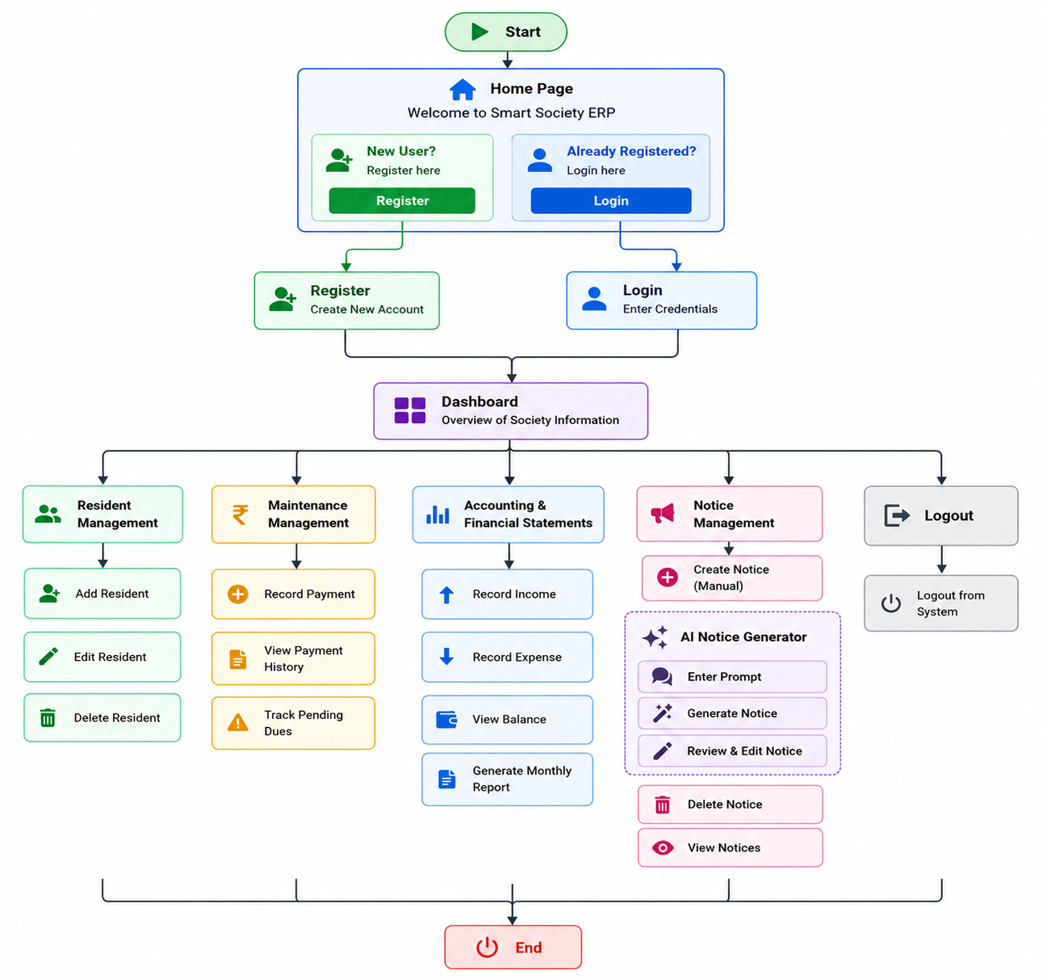

Sketch low-fidelity wireframes for the core flow.
https://www.figma.com/make/IdI9n17TaCX0oj89TRZMFU/Website-Design-Mockups?t=Nn1xwpwbGkRYYvJE-1

